Lesson 5 classroom

Test Case 1

Title: Calculation with empty entry date

Steps:

1. Clear the field “Please input entry date and time”
2. Press the button “Calculate”

Expected result:

The error message “ERROR! ENTER A CORRECTLY FORMATTED DATE” is displayed for the field “ESTIMATED PARKING COSTS”

Attachments:

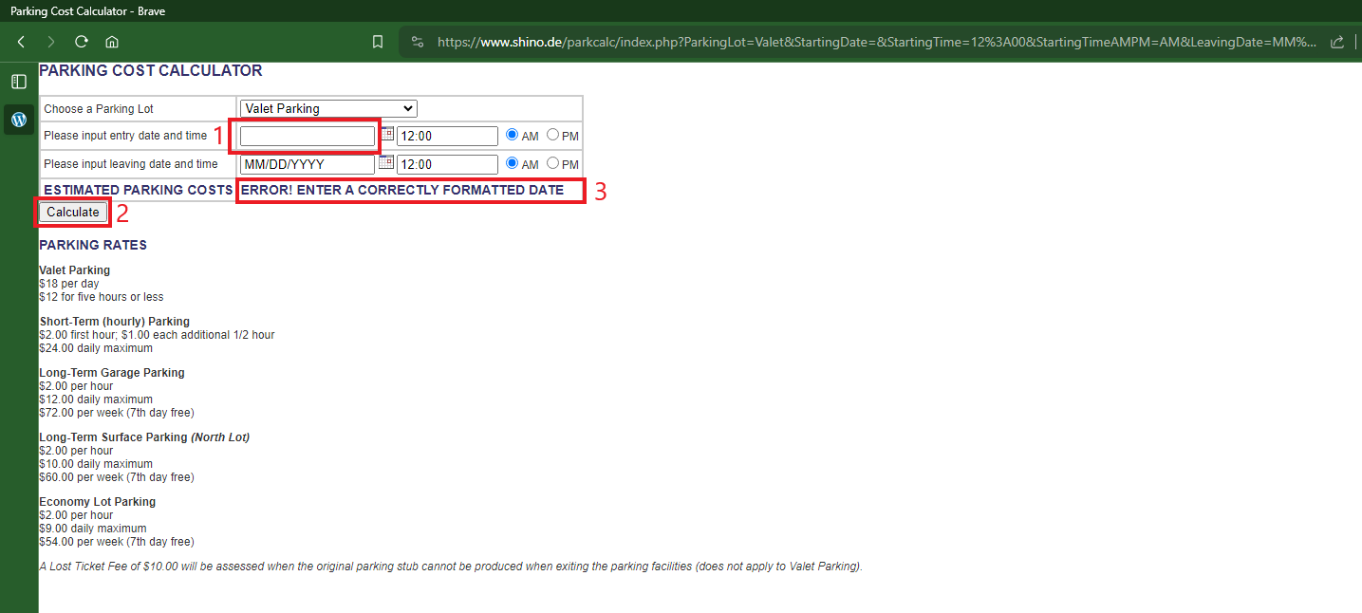

Test Case 2

Title: Calculation with empty entry and leaving date

Steps:

1. Clear the field “Please input entry date and time”
2. Clear the field “Please input leaving date and time”
3. Press the button “Calculate”

Expected result:

The error message “ERROR! ENTER A CORRECTLY FORMATTED DATE” is displayed for the field “ESTIMATED PARKING COSTS”

Attachments:

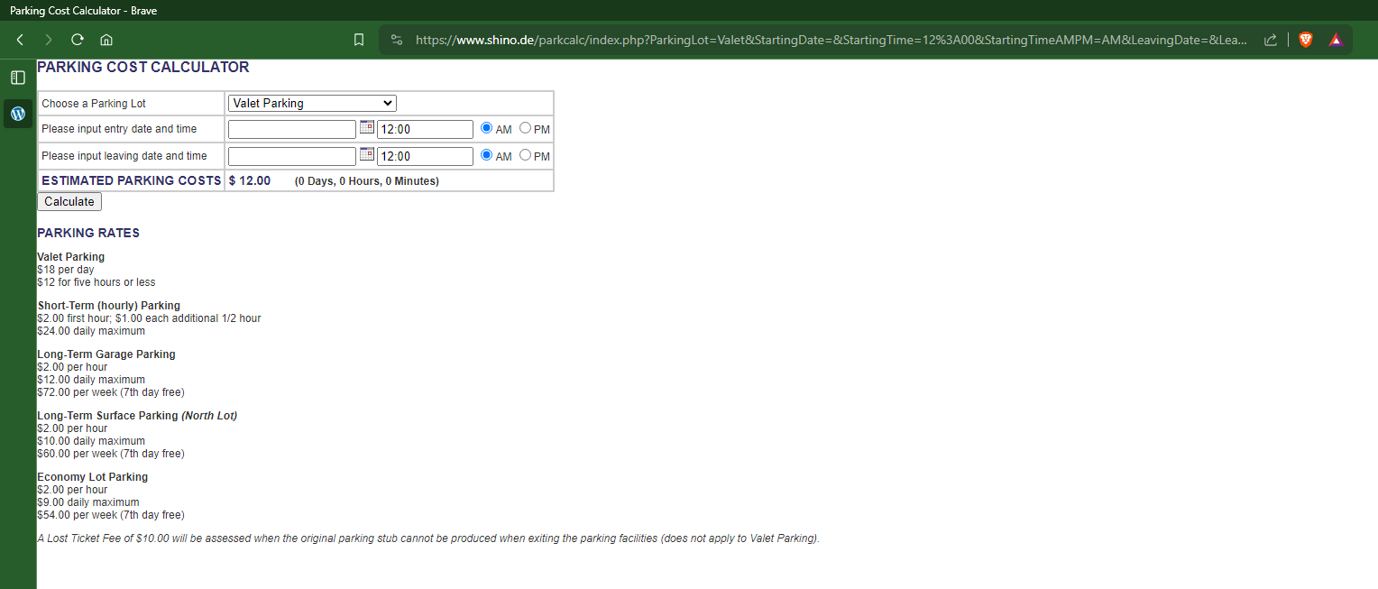

Test Case 3

Title: Calculation with empty entry date field, filled leaving date field

Steps:

1. Clear the field “Please input entry date and time” -> the field is blank
2. Input a valid date in the the field “Please input leaving date and time”, for example, 24.02.2024 -> the field is filled with the selected date in a valid format
3. Press the button “Calculate” -> The error message “ERROR! ENTER A CORRECTLY FORMATTED DATE” is displayed for the field “ESTIMATED PARKING COSTS”

Attachments:

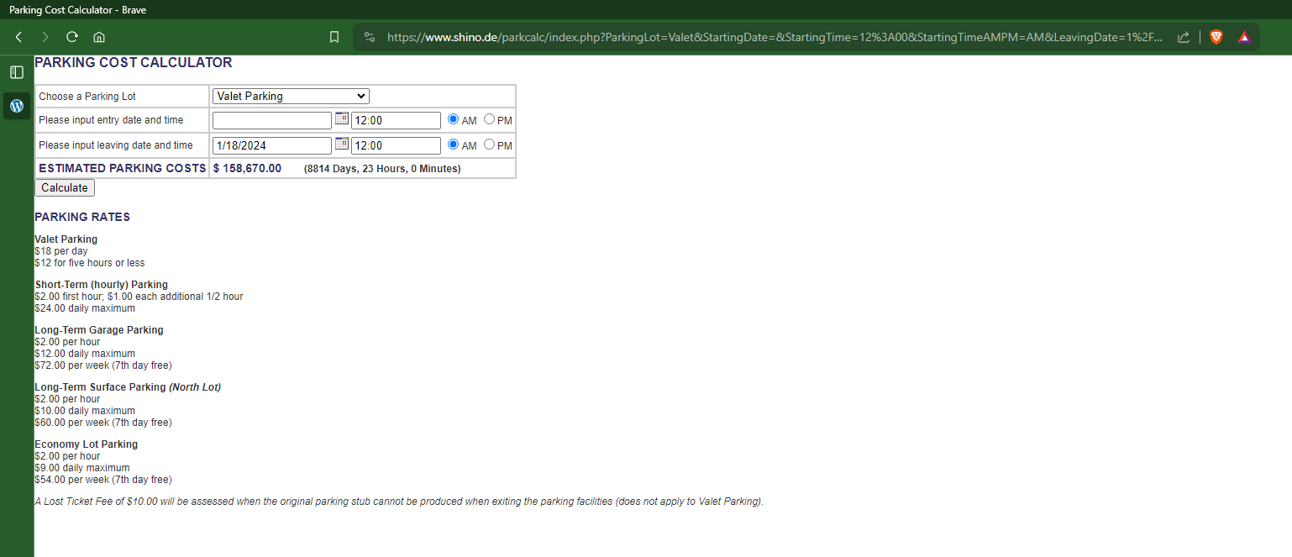

Test Case 4

Title: Calculation with entry date after leaving date

Steps:

1. Open <http://www.shino.de/parkcalc/>
2. Select a valid date for the field “Please input entry date and time”, for example, 25.02.2024
3. Select a date before the entry date for the field “Please input leaving date and time”, for example, 24.02.2023
4. Press the button “Calculate”

Expected result:

The error message “ERROR! YOUR LEAVING DATE OR TIME IS BEFORE YOUR STARTING DATE OR TIME”

Attachments:

Test Case 5

Title: Selecting a value from the dropdown “Choose a Parking Lot”

Steps:

1. Open <http://www.shino.de/parkcalc/>
2. Select the option “Long Term Garage Parking” from the “Choose a Parking Lot” dropdown field
3. Input valid entry date and leaving date in the fields
4. Press the button “Calculate”

Expected result:

The calculation result is displayed. The data in the fields remains the same.

Attachments: